**Project Design Phase**

**Solution Architecture**

|  |  |
| --- | --- |
| Date | 26 JUNE 2025 |
| Team ID | LTVIP2025TMID48508 |
| Project Name | Heritage Treasures: An In-Depth Analysis of UNESCO World Heritage Sites in Tableau |
| Maximum Marks | 4 Marks |

### ****Solution Architecture Goals Applied****

This architecture:

* Bridges business needs (insight into world heritage sites) with tech solutions (Tableau dashboards).
* Defines system components, flow of data, and integration of tools.
* Guides how the data is managed, analyzed, and visualized.
* Enables scalability and user interaction through a BI tool (Tableau).

**Example - Solution Architecture Diagram:**

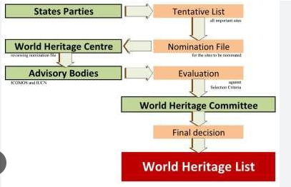

*Figure 1: Architecture of* Heritage Treasures: An In-Depth Analysis of UNESCO World Heritage Sites in Tableau